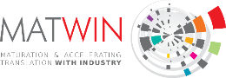
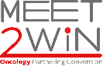
QUICK PITCH
Application form

The QUICK PITCH session is a special session organised during the MEET2WIN European Oncology Partnering Convention. The session showcases a selection of research oriented innovative projects in oncology (no services offers allowed) pitching their project (4/5mn) to the full MEET2WIN audience. The MATWIN International Board composed of leading global industrial decision-makers in oncology R&D from MATWIN’s partners and KOL from major cancer research centers across Europe, will attend the pitch and will select 1 or 2 projects for a longer presentation to the MATWIN Board.

Project presentation (not confidential)

  Identity |   Logo of the organization  (lab or company) in HD
    Organisation:    Location:    Date company creation:    Name/First name (project leader):    Telephone:  e-mail: | [Insert here]

Description of your activity (5 lines max)

Project’s summary (10 lines max)
If selected, this summary will be inserted in the MEET2WIN booklet (please make it easy to understand)

Detailed presentation of the project (1 page max)
- Unmet medical need & problems to be solved
- Scientific & innovative Approach (Technologies and Highlights)
- Development plan (main steps)

Objectives

Partnership objectives and opportunities (3 lines max)
- What are you looking for (partnership, funding, technical expertise, codevelopment offers…)?

The whole file should not exceed 2 pages
Application to be send before Feb 28th 2026 at contact@matwin.fr

