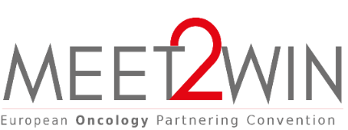
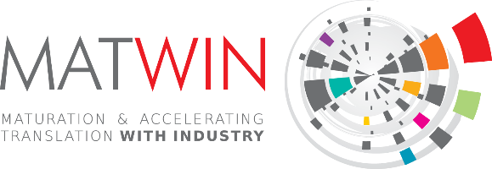
QUICK PITCH - Application form

The QUICK PITCH session is a special session organised during the MEET2WIN European Oncology Partnering Convention. The session showcases a selection of research oriented innovative projects in oncology pitching their project 45mn) to the full MEET2WIN audience in presence of the MATWIN International Board composed of leading global industrial decision-makers in oncology R&D from MATWIN’s partners and KOL from major cancer research centers across Europe. One or two projects selected by MATWIN Board members will have the opportunity to further present their project to the MATWIN Board.

Project presentation

Identity | Logo of the organization (lab or company) in HD
Organisation:  Location:  Name/Firtsname (project leader):  Telephone:  e-mail: | Insert here
Description of your activity (5 lines max)
Project’s summary (10 lines max)
If selected, this summary will be inserted in the MEET2WIN booklet (please make it accessible)
Detailed presentation of the project (1 page max)
- Unmet medical need & problems to be solved
- Scientific & innovative Approach (Technologies and Highlights)
- Development plan (main steps)

Objectives

Partnership objectives and opportunities (3 lines max)
- What are you looking for (partnership, funding, technical expertise, codevelopment offers…)?

The whole file should not exceed 3 pages
Application to be send before February 28th 2022 at contact@matwin.fr

