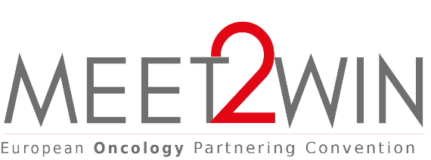
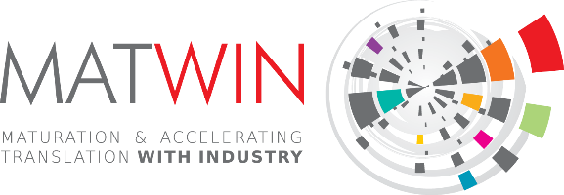

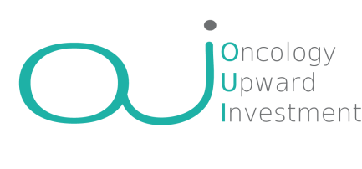
- Application form

OUI (Oncology Upward Investment) session is part of the MEET2WIN European Oncology Partnering Convention. Co-organized by MATWIN, and Angels Santé. OUI aims at showcasing innovative startups in oncology to a panel of European investors able to support their growth (pre-seed & seed funds, venture capital, foundations, etc.). Selected projects will have the opportunity to:
      - benefit from a personalized coaching support to help them to optimize their pitch
- pitch (10 minutes max) in front of a panel of investors and optimise their opportunity of collaboration and funding

Company Presentation

Identity | Logo of the company (in HD)
Name of the company:  Location:  Name of the manager:  Telephone:  e-mail: | Insert here
Activity summary (5 lines)
Presentation of the company (15 lines)
Management Team and Members of the Board (just list members)

Scientific information

Unmet Medical need & problems to be solved

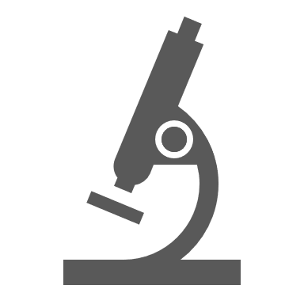
Scientific Approach
(Expertise, Technologies, Highlights
and Ongoing Collaborations)
Innovation and Intellectual Property
(if none, why?)
Development Plan
(scientific, technological and clinical)

Financial information

Market & Competitive landscape
Development Plan & Business Model
(Financial, business and Human Ressources, Fundraising needs)

The whole file should not exceed 5 pages
Application to be send before February 28th 2022 at contact@matwin.fr

